Welcome to Microsoft Mainframe

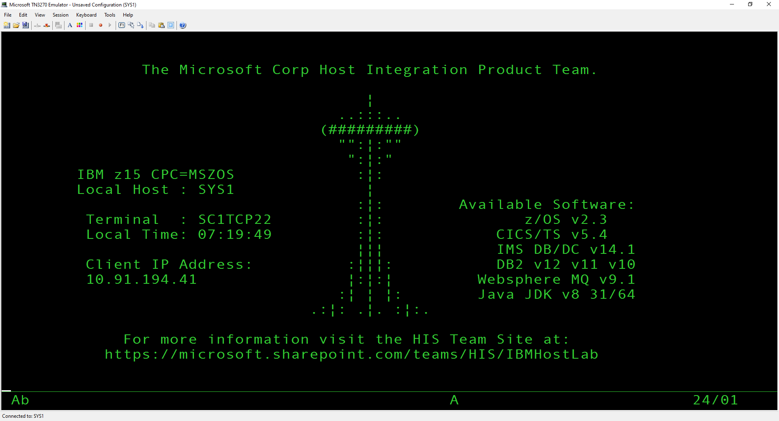

WBAC - Add a Customer
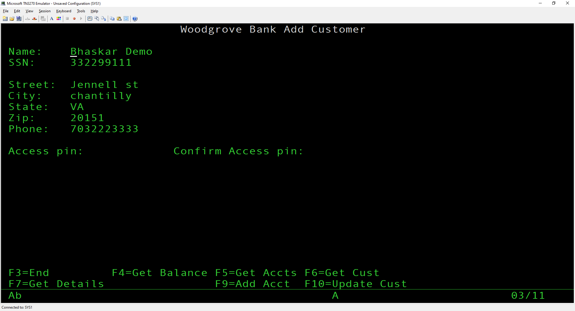

WBAA - Add a checking or savings account to a Customer
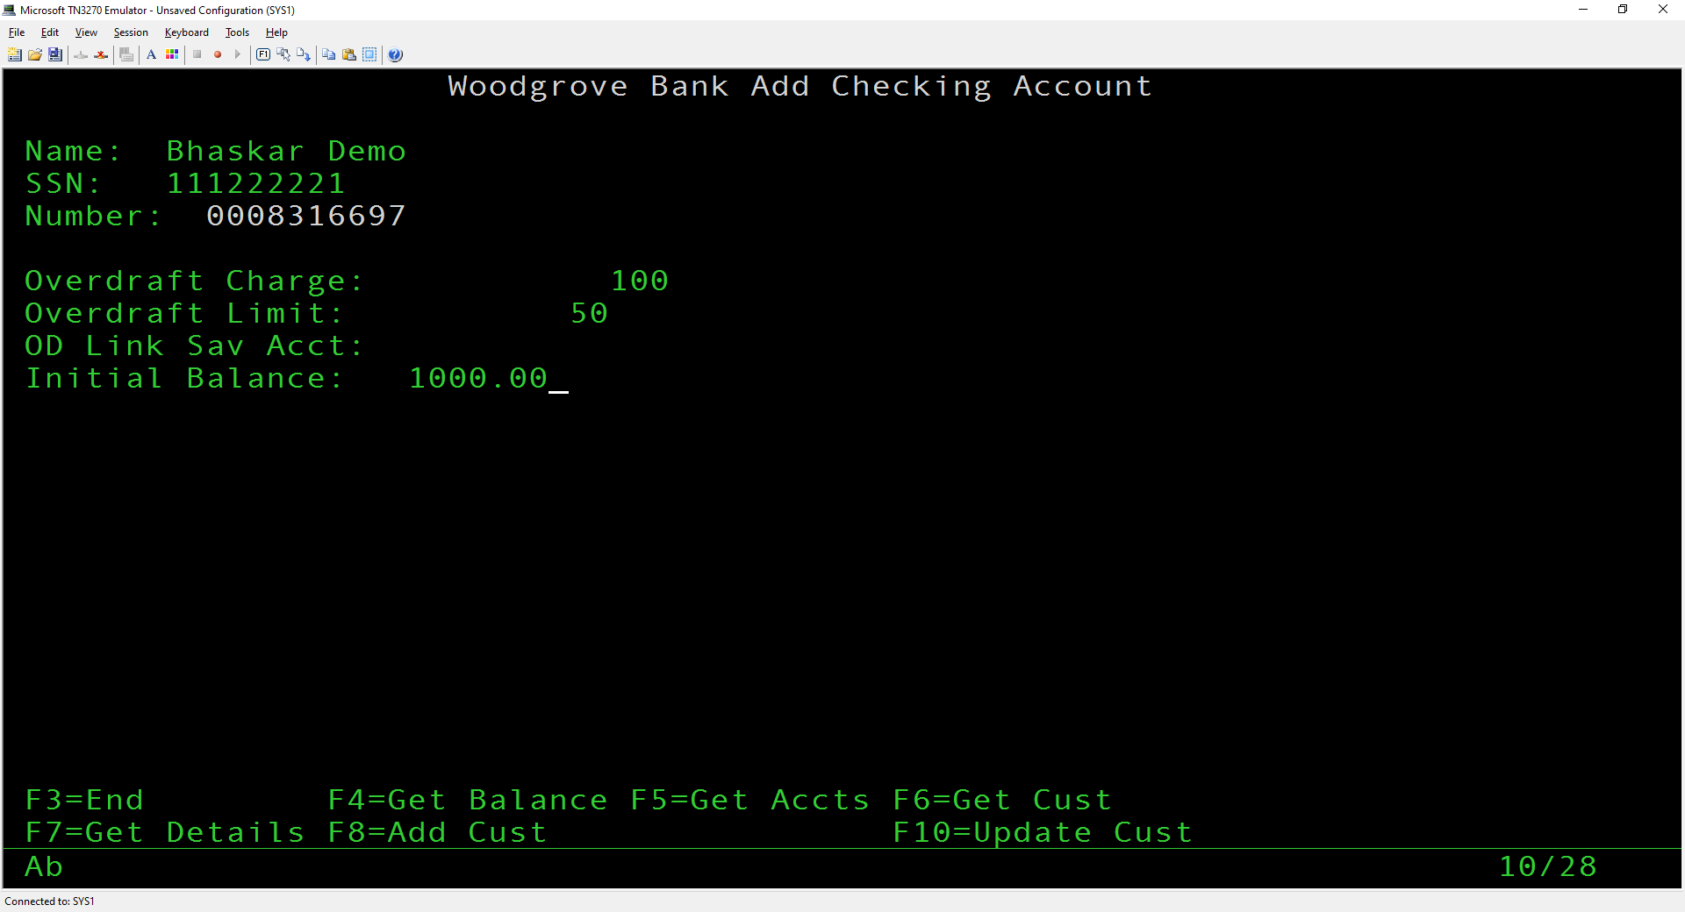
Account successfully added
Checking 0008316697 Bhaskar Demo
WBGD - Get Account Details (Debits and Credits for each Customer Account
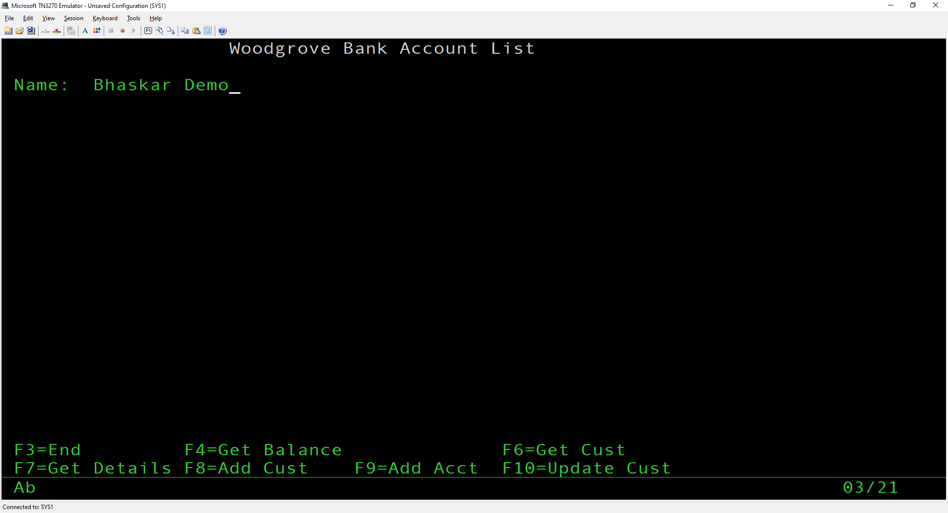
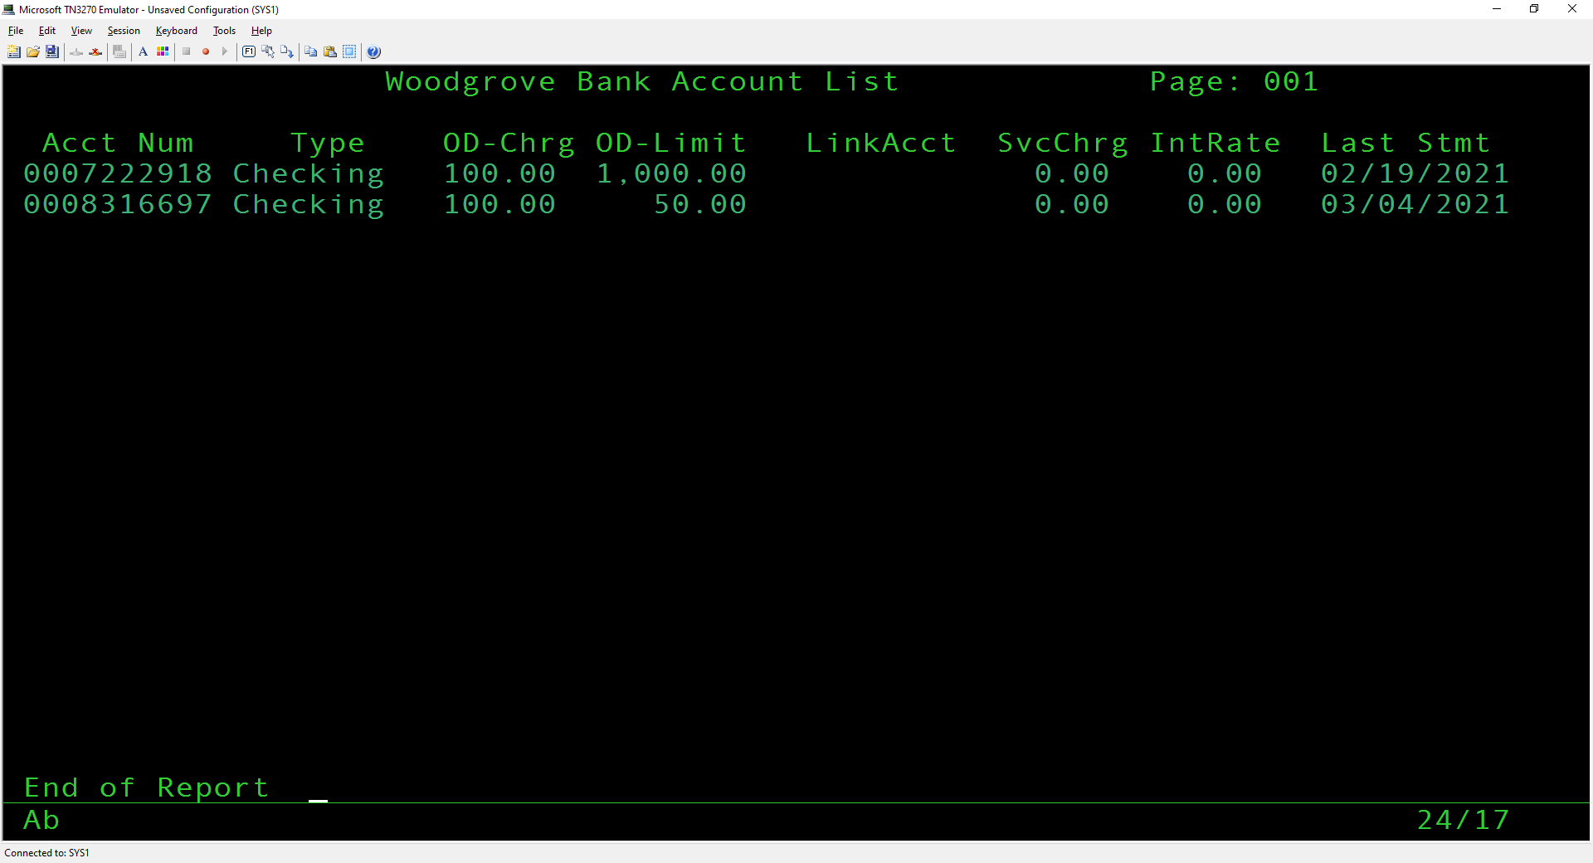

WBGC - Get Customers (Get a list of customers)
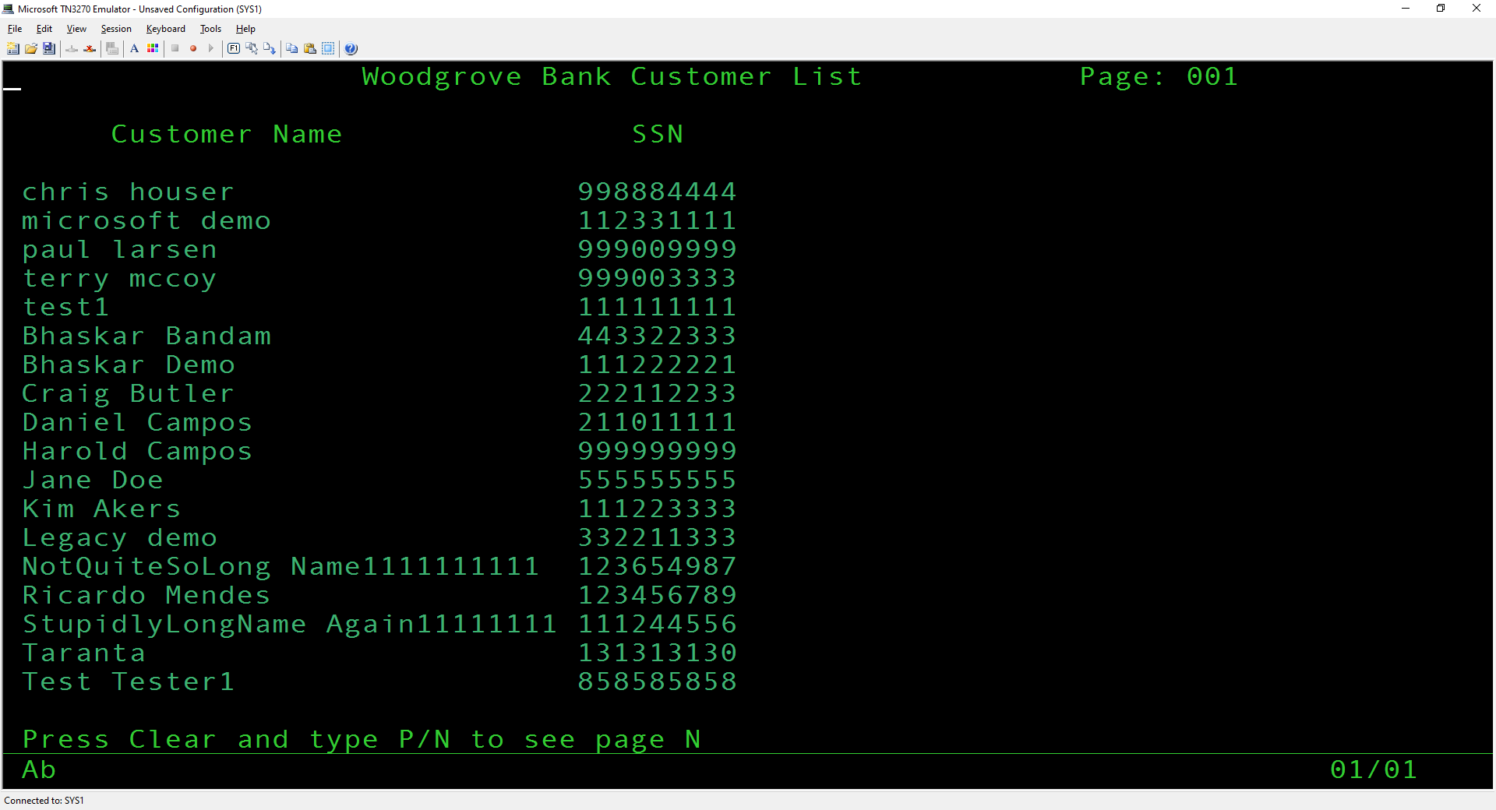

WBGB - Get Balance (Get the balance of an account for a customer)

